RIFD-NET: A ROBUST IMAGE FORGERY DETECTION NETWORK
Abstract:
In the digital age, image forgery has become increasingly prevalent due to the widespread availability of image editing tools, posing significant threats to information authenticity. Detecting forged images, especially those manipulated through copy-move, splicing, or removal, requires advanced and robust methods. RIFD-NET (Robust Image Forgery Detection Network) is a deep learning-based approach that addresses this challenge by automatically learning hierarchical features to distinguish between authentic and manipulated image regions. By utilizing a convolutional neural network (CNN) architecture, RIFD-NET effectively captures both low-level and high-level image inconsistencies, making it suitable for a wide variety of forgery types. This approach aims to improve detection accuracy and robustness under different post-processing conditions such as compression, scaling, and noise addition.

Existing System:
Traditional image forgery detection techniques rely heavily on handcrafted features and statistical inconsistencies within images. These systems typically use techniques like Error Level Analysis (ELA), Discrete Cosine Transform (DCT), or edge detection to identify tampered regions. While these methods can detect certain types of forgeries, they often fail under sophisticated editing operations or when the image undergoes post-processing like JPEG compression or blurring. Moreover, these approaches usually require manual parameter tuning and prior knowledge of forgery patterns, which limits their scalability and adaptability in real-world scenarios.

Existing System Disadvantages:
• Ineffective against complex and subtle forgeries.
• Poor robustness to image post-processing (e.g., compression, scaling, noise).
• Heavy reliance on handcrafted features and prior domain knowledge.

Proposed System:
The proposed system, RIFD-NET, introduces a deep learning-based architecture that automatically learns and extracts discriminative features from images to detect forgery with higher accuracy. Unlike traditional methods, RIFD-NET employs a CNN that is trained on a large dataset of forged and authentic images. This allows the model to capture minute inconsistencies and patterns that are often invisible to the human eye or traditional algorithms. Furthermore, the network is designed to be robust against common image transformations, making it highly effective across a variety of scenarios. With end-to-end training and automatic feature learning, RIFD-NET significantly outperforms classical techniques in terms of precision, recall, and overall detection performance.

Proposed System of Advantages:
• Automatically learns robust features without manual intervention.
• High accuracy and precision in detecting multiple types of forgeries.
• Resilient to image post-processing effects like compression and blurring.

System Architecture:

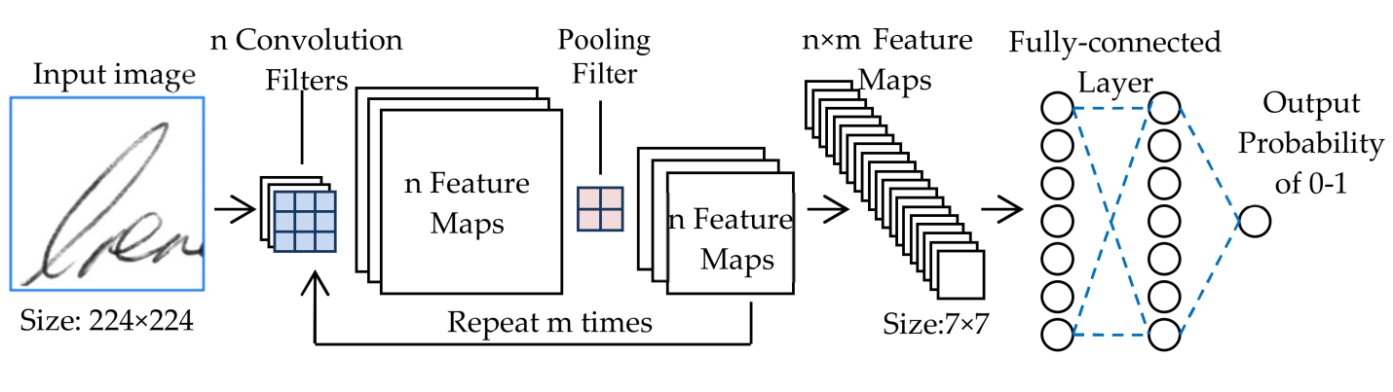

SYSTEM REQUIREMENTS:

HARDWARE REQUIREMENTS:

• System : Pentium IV 2.4 GHz.
• Hard Disk : 40 GB.
• Ram : 512 Mb.

SOFTWARE REQUIREMENTS:

• Operating system : - Windows.
• Coding Language : python.

